Created by Samoilov Philipp
Form 3 I
School 1862

The Story of Doctor Dolittle.

The author of the book is Hugh Lofting. This story is about John Dolittle.
He was a doctor. He lived in a little town called Puddleby-on-the Marsh.
He wore a high hat. He was a very clever man.
He loved animals very much and kept many pets.
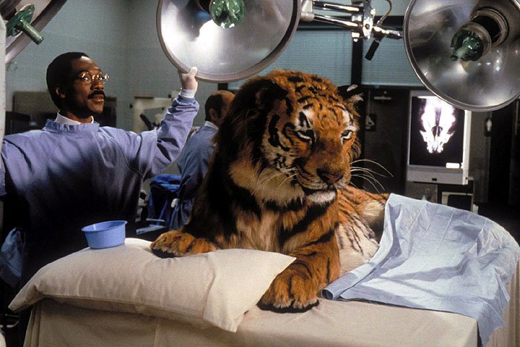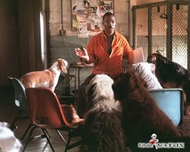

His favorite pets were Dad-Dad the duck, Jip the dog and Polynesia the parrot.

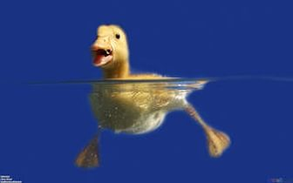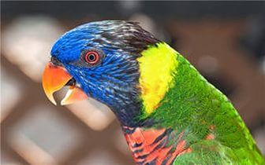

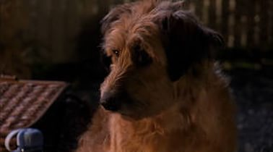

People didn`t want to visit the doctor because there were a lot animals in his small house.
Only the Cat`s-meat-Man came, because he liked all animals.
This man advised him to be an animal doctor. Many people had pets at home.
Polynesia the parrot taught him birds` language. The doctor learnt the language of the animal and he could talk to them.

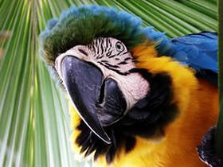

People began to bring him their pets. The pets were very happy. Doctor Dolittle was happy too.

