Pirates of the Caribbean

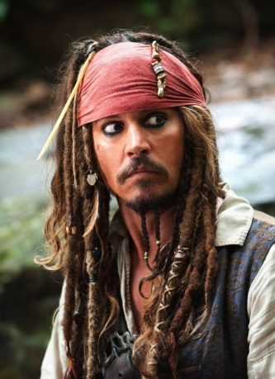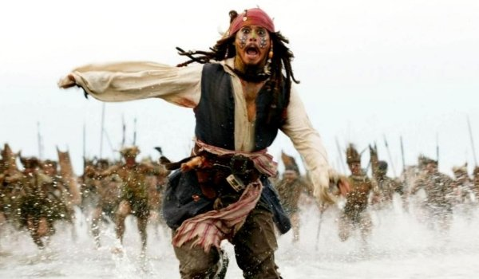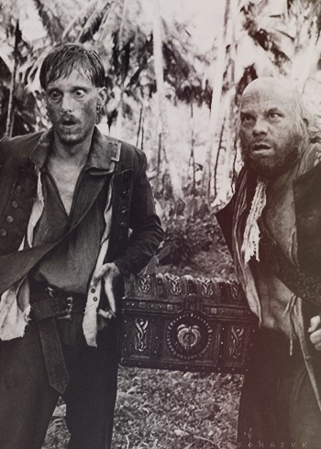
The movie I want to write about is the beautiful creation of the talented director Gor Verbinski. This movie is “Pirates of the Caribbean”.
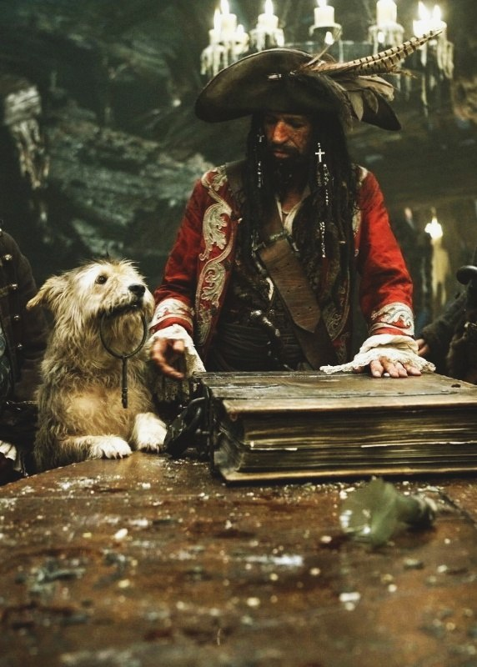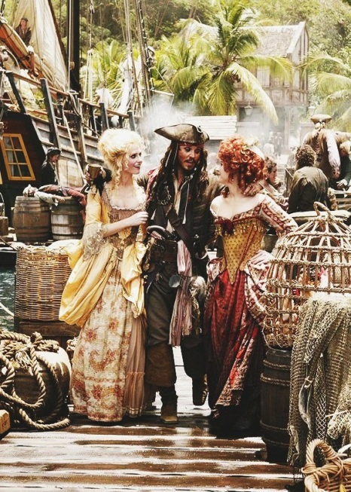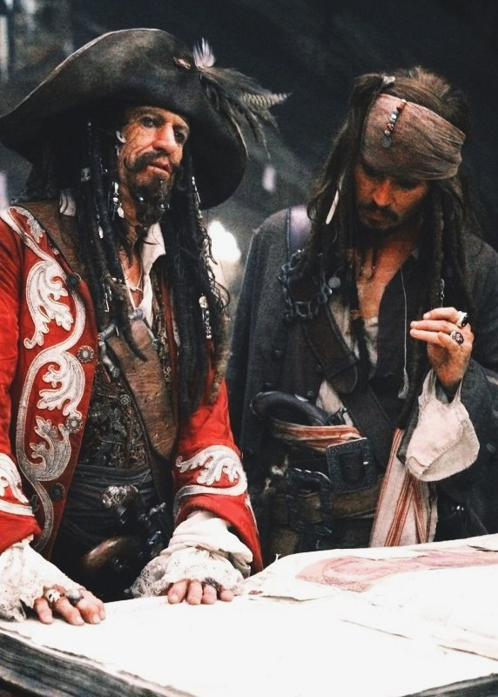
This fantastic movie consists of four parts, and I can't solve which of them is pleasant for me more, therefore I will tell about all of them. The main characters of the movie are captain Jack Sparrow who was played by incomparable Johnny Depp, Elisabeth Swan and Will Turner, played by beautiful Keira Knightley and brutal Orlando Blum.
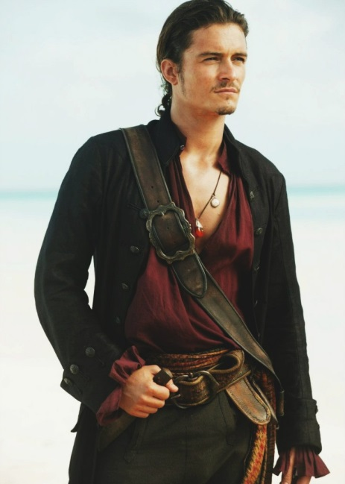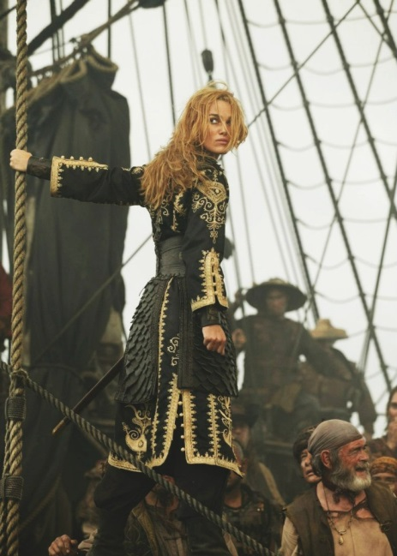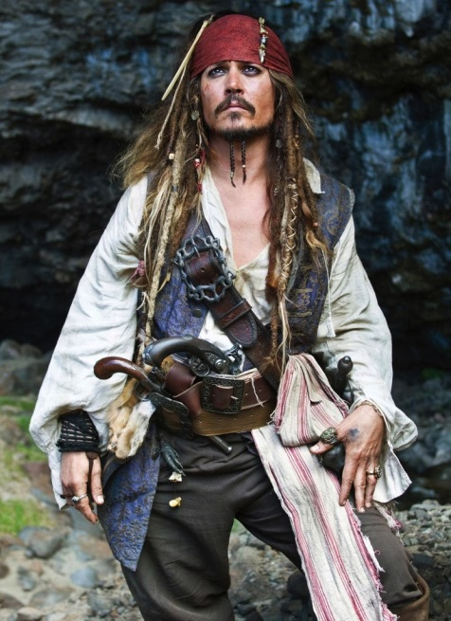
The first part narrates about adventures, in which captain Jack Sparrow is compelled to be engaged in prosecution of his enemy, the former assistant Hector Barbossa, who stole captain’s ship "The Black Pearl".
The main intrigue in the second part is developed round a chest of Davy Jones. Jack is searching for a key that will unlock the chest.
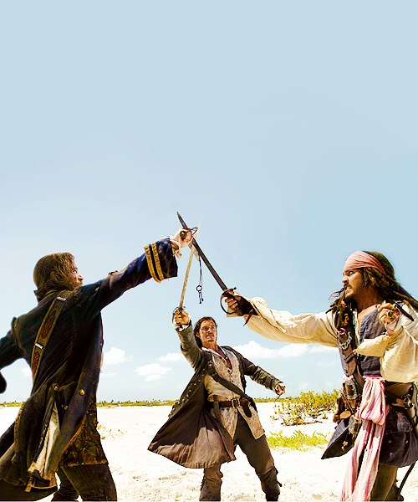
The third part tells us about Elisabeth Swan, the captain Barbossa and Will Turner who were in searches of Jack Sparrow.
The fourth part tells us about Jack Sparrow’s hunting for immortality that will involve him in various adventures again and again. Jack Sparrow meets the former love Angelica and gets on the ship that is operated by the Black Beard.

What is pleasant about this movie? In total, everything is. Acting, plot, work of the operator, installation, incredibly interesting characters, subject lines - everything is ideal. Every actor plays unsurpassedly - it is simply impossible to turn the film off, you become a part of this movie as if you’re one of the heroes. The film carries you away to the mysterious world of pirates, traveling and adventures.

I adore this movie since 2007, when there was the third part. Every year I review the parts and test my emotions, they are the same as at the first viewing. If you didn't see this movie, you are simply obliged to watch it.
