Колтунов Денис МБОУ СОШ №18
4 класс
р. Адыгея г. Майкоп
Harry Potter is the name that every child knows nowadays all over the world. There is no person who wouldn`t like to receive a letter from Hogwarts. But fortunately we have the chance to feel this magical world with amazing books written by J. K. Rowling and Harry Potter film series, without taking into account computer games and other entertainments created according these books.
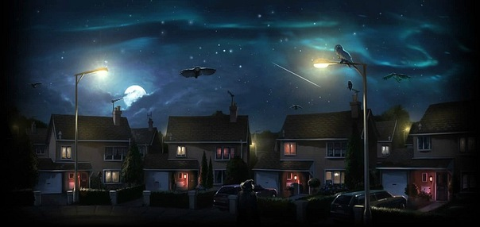
The Harry Potter film series is a British-American film series based on the Harry Potter novels by the British author J. K. Rowling. The film consists of 8 fantasy films, beginning with Harry Potter and the Philosopher`s stone in 2001 and ending by Harry potter and the Deathly Hallows Part 2 in 2011. In 1997 film producer David Heyman received a copy of the first book and was impressed by Rowling`s work. He began the process that led to one of the most successful cinematic franchise of all time. Later the film had 4 directors : Chris Columbus, Alfonso Cuaron, Mike Newell and David Yates. Production of the movie took over ten years.
Harry Potter is a very cool movie and a book thanks to the magical world, atmosphere of the castles and teachers.

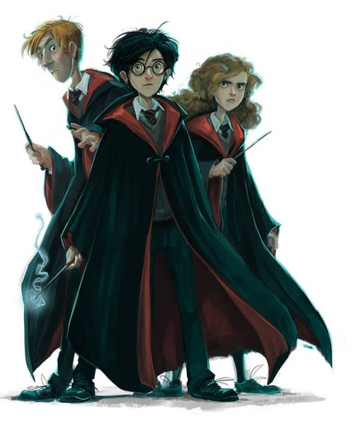
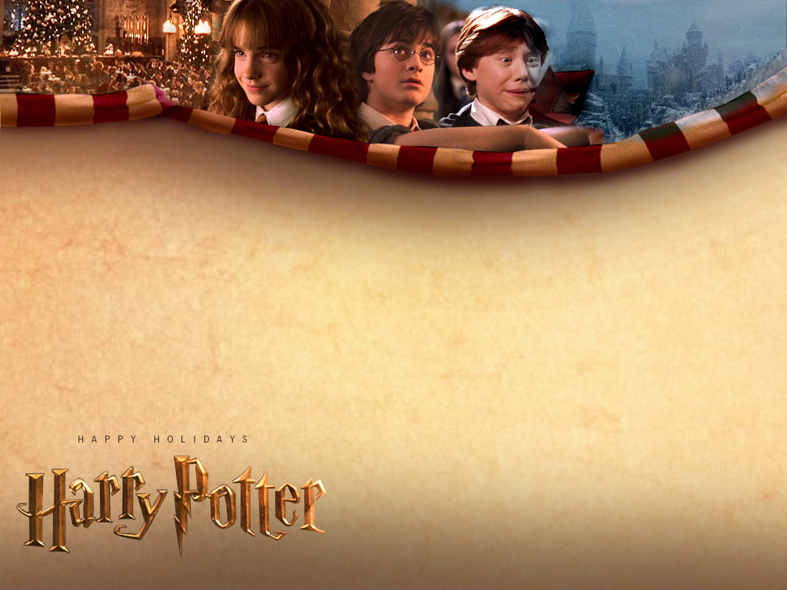 Harry is a boy whose parents were killed by an evil man Volan de Mort.
Every film has different object but they are linked by central idea- a war between bad and good magiciens, the friendship and love.

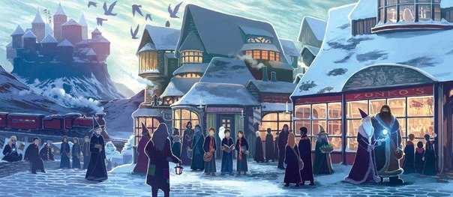
The whole story friends try to win the evil magicians. But it`s only Harry who can stop him. So Harry Potter`s parents died protecting him and then Harry grows and his friends help him to overcome Volan de mort with the help of love.
There are also funny and happy moments of their life, lessons, school, games in Kwidich- the elements that attracts most of all

You can trust me that this is one of the most interesting books and films of all times. It teaches many things: friendship, kindness, sense of humor, love…
And the most important that this story opens the world of reading books, Makes you to look for more adventures in other books.
As for me I want to watch this movie and to read these books over and over again.
That is why I like it and suggest you also to enter this magical world.
