Goal! (2005)
"Every dream has a beginning"- that is the slogan of the most inspiring film I have ever seen. Goal!, directed by Danny Cannon, was released in 2005. It is one of the truly great sports stories of our time. When I watched this film, I realized that nothing is impossible. You can achieve your goal if we work hard for it, work whole-heartedly and be sure that opportunity never misses. You should always believe in yourself and never give up. I have been playing football for a long time and I understand how hard it is to achieve something in sport. Now Goal! is on my Top 10 list and I suppose it is a must-see, even if you are not too fond of sports dramas.
The plot is unusual in all senses of the word. It is both predictable and unbelievable at the same time. Santiago Munez, who really has the ability to be a genuine footballer, is an ordinary boy from a poor Mexican family. He's struggling to make ends meet, but every spare minute he devotes to football. He represents millions of talented boys who want to play football for a world class team. One day, playing with friends, Santiago is noticed by Glen Foy, a former footballer and scout, who asks him to come to England for a tryout with Newcaslte United.
Despite his asthma and shortage of money Santi overcomes trials of different kinds and gets in. Santiago's life changes very much. Santiago finds himself totally alone in a world where football is a religion and the players are gods. Now he has to prove he has the passion, talent and determination to play alongside the best in the world. He becomes a professional footballer and plays for Newcaslte United. The film shows footballers' everyday life, full of hard trainings, serious injuries, crowded stadiums, sweat and delight.
While the story itself is a fine piece of work, it's the cast that elevates Goal! to an outstanding, emotional and spectacular film. Kuno Becker is astonishing in his role as Santiago Munez. The film is notable for the large number of cameo appearances, such as David Beckham, Zinedine Zidane, Alan Shearer and some other world- famous football players. Actual teams and players are used throughout the film.
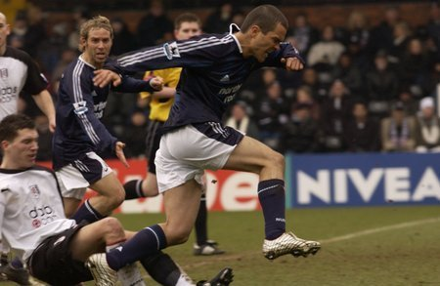

"Goal" this is a serious sports drama and the main message of it is that person who believes in dream and in his power to achieve it, can have everything in life! Watch and enjoy the atmosphere of this film! If you’re looking for motivating touch, this is undoubtedly the movie for you.

