A Book Review
«The world breaks everyone; and
afterward, some are strong
at the broken places»
E. Hemingway

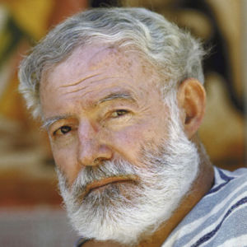
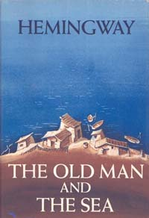
One of my favourite books is « The Old Man and The Sea». It is a novel written by the American author Ernest Hemingway in 1951 in Cuba, and published in 1952.
Ernest Hemingway was born in 1951 in Chicago, the USA. His mother was a musician, and his father was a doctor. The life of Ernest Hemingway was not very long, but it was full of dramatic events. He went through two World wars, the Civil war in Spain. He was fishing in the Atlantic Ocean and was hunting in Africa. He was fond of Spanish bull-fighting and knew it quite well. He was an excellent boxer, yachtsman, swimmer, sniper, and mountain-climber. He felt and understood people and nature, was very attentive and careful. He noticed everything. Hemingway was honest and brave. He knew what «hard work» meant.
The main characters of the novel are the old man Santiago and the boy named Manolin.
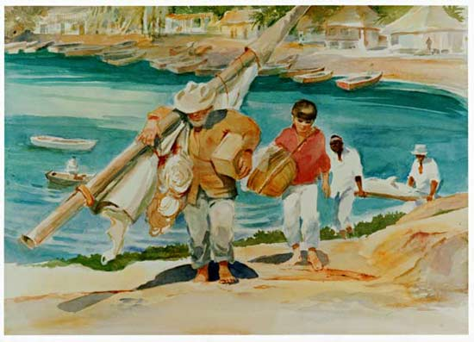
For 84 days, the old fisherman Santiago has caught nothing. Alone, impoverished, and facing his own mortality, Santiago is now considered unlucky. Every evening, though, when Santiago again returns empty-handed, Manolin helps carry home the old man's equipment, keeps him company, and brings him food.

In the morning of the 85th day, Santiago sets out before dawn on a three-day voyage that takes him far out to sea. He catches a great fish. He straps the marlin along the length of his skiff and heads for home, hardly believing his own victory. Within an hour, a shark attacks the marlin, tearing away a great part of its flesh. Santiago fights the shark, with great suffering, and eventually kills it with his harpoon, which he loses in the struggle.
The great tear in the marlin's flesh releases the fish's blood and scent into the water, attracting packs of sharks. Santiago fights off the packs of these dangerous fish. The old man is exhausted and has a great physical pain. Eventually, the sharks pick the marlin clean. Defeated, Santiago reaches shore. Alone in the dark, he looks back at the marlin's skeleton.
The next morning, Manolin finds Santiago in his hut and cries over the old man's injuries. Manolin fetches coffee and hears from the other fisherman what he had already seen. The marlin's skeleton is eighteen feet long, the greatest fish the village has known. Manolin sits with Santiago until he awakes and then gives the old man some coffee. The old man tells Manolin that he was beaten. But Manolin reassures him that the great fish didn't beat him and that they will fish together again, that luck doesn't matter, and that the old man still has much to teach him.
I liked the book for a number of reasons. The author has created an amazing marine world. The story is striking and I found it difficult to put down. The characters are convincing and I identified strongly with Manolin. I love all the twists in this book. It is a story about hope. It shows that even in the face of certain death we as people can still smile, hold our heads up high, honour those we love and stay true to the people we are.
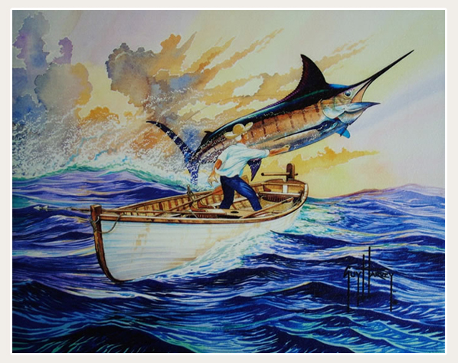
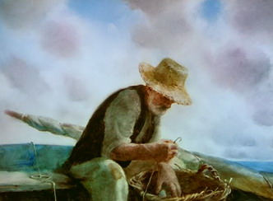
I thoroughly recommend this book to all teenagers and my friends. By the way, Ernest Hemingway was awarded the Nobel Prize in 1954 for this novel. To my mind, it is a must-read for all the teenagers.

