"Harry Potter and the Philosopher's Stone."

I like this film very much and I decided to dedicate my review to my favourite film "Harry Potter and the Philosopher's Stone." This movie is based on the novel of J.K. Rolling. This is the first part of the book series about the adventures of young wizard Harry Potter. The film was shot by a famous American director Chris Columbus, known for such masterpieces as the comedy "Home Alone." "Harry Potter and the Philosopher's Stone" - is only the first part of a great story. But here for first time we see the main characters, learn their nature and characteristics. The film drags at once thanks to the excellent plot and beautiful scenery. Director with the help of computer graphics could show amazing creatures - goblins, dragons, trolls. The film is impregnated with an unforgettable atmosphere that prevailed in the book.
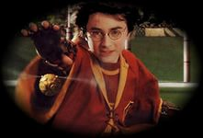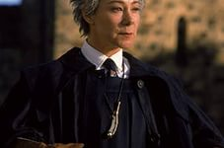
The story is about the boy Harry. He lives with his uncle and aunt, who don’t love him. They harassed him every way, but he doesn’t have another variants. His parents died in a car accident and he is an orphan. But on his 11th birthday, he learns that he is the magician and is invited to study at Hogwarts School of Wizardry. Hagrid,(who delivered the letter) explains to the young wizard the cause of the scar on his forehead and the real circumstances of the death of his parents. They were killed by the evil wizard Volan de Mort. Harry learns that he was also cursed by the evil wizard, but miraculously survived. After buying (with the help of Hagrid) everything necessary, Potter goes to magic school. There he finds his true friends, learn magic and goes through various adventures. Despite of the fact that the school seems to be all quiet, after arrival of Harry odd things concerned with Volan de Mort start to happen. Over time, Harry learns about his devious plan to steal the Philosopher's Stone, which gives immortality. The young wizard is eager to stop him. With the help of his friends, he manages to break the plans of Volan de Mort.
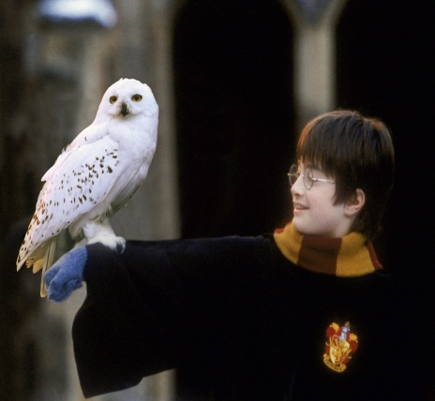
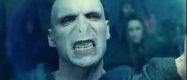
The film, on the background of a magical atmosphere, talks about simple things and values, which in fact is often neglected. He teaches kindness, honesty, loyalty and true friendship. Great music and great acting, of course, complete the dynamic plot. Director created a fairy tale can please all the ages.

